Name /عبدالله حافظ سعد عبد الحليم بدر

B.N / 470

Sec / 21

DATE - 6/5/2021

Topic: Computer Engineering Role in COVID-19 Pandemic

Application brief /

A Brief Review on How Computer Science and Information Technology Can Help Shape the Future of Food Safety.
The COVID-19 pandemic is affecting all businesses and the food industry in particular, posing new challenges for the next future. In a short time, industry had to deal with new plans and protocols in order to reduce the risk of exposure to the coronavirus ensuring that employees remain healthy. This meant introducing distancing measures, updating Personal Protective Equipment (PPE) requirements, wiping down surfaces and equipment on a regular basis and adapting delivery procedures. In addition to issues that are affecting all businesses, food industry has and will have additional challenges to deal with. People will always need to eat and so safe, high quality food must still be produced and provided to customers. Food safety represents the primary concern of all manufacturers, but this should now encompass actions to slow down, as much as possible, the spread of the coronavirus. Even though there is no evidence that the virus can be transmitted via food or food packaging, there is evidence that it can remain viable on certain surfaces for a longer period. The present paper reports a brief review on how the profitable combination of computer science and information technology can help shape the future of food safety. The literature review has been conducted by considering scientific contributions and official resources published by the main international governmental organizations and technical institutions. Some of the cited sources include World Health Organization (WHO), Food and Agriculture Organization (FAO), International Telecommunication Union (ITU) and the Institute of Electrical and Electronics Engineers (IEEE). As the COVID-19 pandemic is unprecedented and still ongoing around the world to date, the literature review was limited to contributions published no more than two years ago. Information and communication technology (ICT) and computer science applications are already present in industry. Despite this, the challenges the world will have to face in the next future to stem the spread of the COVID-19 pandemic require further interdisciplinary and synergistic efforts. In this framework, technology can play a key role in help shaping the future of industry and food safety in particular.
industry had to deal with new plans and protocols in order to reduce the risk of exposure to the coronavirus ensuring that
employees remain healthy. is meant introducing distancing measures, updating Personal Protective Equipment (PPE) requirements,
wiping down surfaces and equipment on a regular basis and adapting delivery procedures. In addition to issues that are aecting all
businesses, food industry has and will have additional challenges to deal with. People will always need to eat and so safe, high quality
food must still be produced and provided to customers.
Food safety represents the primary concern of all manufacturers, but this should now encompass actions to slow down, as much as
possible, the spread of the coronavirus. Even though there is no evidence that the virus can be transmitted via food or food packaging,
there is evidence that it can remain viable on certain surfaces for a longer period. e present paper reports a brief review on how the
protable combination of computer science and information technology can help shape the future of food safety.
e literature review has been conducted by considering scientic contributions and ocial resources published by the main international
governmental organizations and technical institutions. Some of the cited sources include World Health Organization (WHO), Food
and Agriculture Organization (FAO), International Telecommunication Union (ITU) and the Institute of Electrical and Electronics
Engineers (IEEE). As the COVID-19 pandemic is unprecedented and still ongoing around the world to date, the literature review was
limited to contributions published no more than two years ago.
Information and communication technology (ICT) and computer science applications are already present in industry. Despite this, the
challenges the world will have to face in the next future to stem the spread of the COVID-19 pandemic require further interdisciplinary
and synergistic eorts. In this framework, technology can play a key role in help shaping the future of industry and food safety in
particular
industry had to deal with new plans and protocols in order to reduce the risk of exposure to the coronavirus ensuring that
employees remain healthy. is meant introducing distancing measures, updating Personal Protective Equipment (PPE) requirements,
wiping down surfaces and equipment on a regular basis and adapting delivery procedures. In addition to issues that are aecting all
businesses, food industry has and will have additional challenges to deal with. People will always need to eat and so safe, high quality
food must still be produced and provided to customers.
Food safety represents the primary concern of all manufacturers, but this should now encompass actions to slow down, as much as
possible, the spread of the coronavirus. Even though there is no evidence that the virus can be transmitted via food or food packaging,
there is evidence that it can remain viable on certain surfaces for a longer period. e present paper reports a brief review on how the
protable combination of computer science and information technology can help shape the future of food safety.
e literature review has been conducted by considering scientic contributions and ocial resources published by the main international
governmental organizations and technical institutions. Some of the cited sources include World Health Organization (WHO), Food
and Agriculture Organization (FAO), International Telecommunication Union (ITU) and the Institute of Electrical and Electronics
Engineers (IEEE). As the COVID-19 pandemic is unprecedented and still ongoing around the world to date, the literature review was
limited to contributions published no more than two years ago.
Information and communication technology (ICT) and computer science applications are already present in industry. Despite this, the
challenges the world will have to face in the next future to stem the spread of the COVID-19 pandemic require further interdisciplinary
and synergistic eorts. In this framework, technology can play a key role in help shaping the future of industry and food safety in
particular
industry had to deal with new plans and protocols in order to reduce the risk of exposure to the coronavirus ensuring that
employees remain healthy. is meant introducing distancing measures, updating Personal Protective Equipment (PPE) requirements,
wiping down surfaces and equipment on a regular basis and adapting delivery procedures. In addition to issues that are aecting all
businesses, food industry has and will have additional challenges to deal with. People will always need to eat and so safe, high quality
food must still be produced and provided to customers.
Food safety represents the primary concern of all manufacturers, but this should now encompass actions to slow down, as much as
possible, the spread of the coronavirus. Even though there is no evidence that the virus can be transmitted via food or food packaging,
there is evidence that it can remain viable on certain surfaces for a longer period. e present paper reports a brief review on how the
protable combination of computer science and information technology can help shape the future of food safety.
e literature review has been conducted by considering scientic contributions and ocial resources published by the main international
governmental organizations and technical institutions. Some of the cited sources include World Health Organization (WHO), Food
and Agriculture Organization (FAO), International Telecommunication Union (ITU) and the Institute of Electrical and Electronics
Engineers (IEEE). As the COVID-19 pandemic is unprecedented and still ongoing around the world to date, the literature review was
limited to contributions published no more than two years ago.
Information and communication technology (ICT) and computer science applications are already present in industry. Despite this, the
challenges the world will have to face in the next future to stem the spread of the COVID-19 pandemic require further interdisciplinary
and synergistic eorts. In this framework, technology can play a key role in help shaping the future of industry and food safety in
particular
industry had to deal with new plans and protocols in order to reduce the risk of exposure to the coronavirus ensuring that
employees remain healthy. is meant introducing distancing measures, updating Personal Protective Equipment (PPE) requirements,
wiping down surfaces and equipment on a regular basis and adapting delivery procedures. In addition to issues that are aecting all
businesses, food industry has and will have additional challenges to deal with. People will always need to eat and so safe, high quality
food must still be produced and provided to customers.
Food safety represents the primary concern of all manufacturers, but this should now encompass actions to slow down, as much as
possible, the spread of the coronavirus. Even though there is no evidence that the virus can be transmitted via food or food packaging,
there is evidence that it can remain viable on certain surfaces for a longer period. e present paper reports a brief review on how the
protable combination of computer science and information technology can help shape the future of food safety.
e literature review has been conducted by considering scientic contributions and ocial resources published by the main international
governmental organizations and technical institutions. Some of the cited sources include World Health Organization (WHO), Food
and Agriculture Organization (FAO), International Telecommunication Union (ITU) and the Institute of Electrical and Electronics
Engineers (IEEE). As the COVID-19 pandemic is unprecedented and still ongoing around the world to date, the literature review was
limited to contributions published no more than two years ago.
Information and communication technology (ICT) and computer science applications are already present in industry. Despite this, the
challenges the world will have to face in the next future to stem the spread of the COVID-19 pandemic require further interdisciplinary
and synergistic eorts. In this framework, technology can play a key role in help shaping the future of industry and food safety in
particular

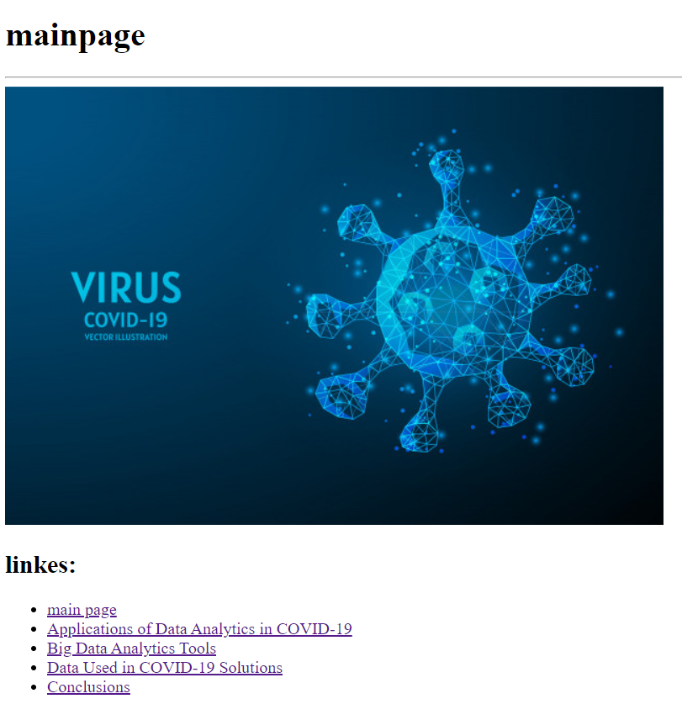
screen shots:

